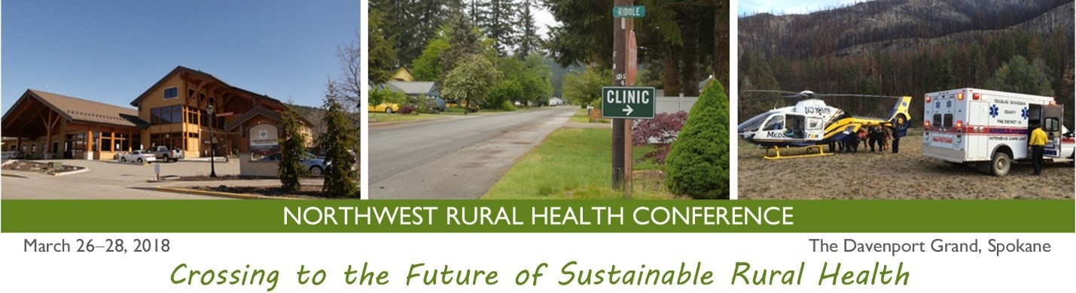

Northwest Rural Health Conference
March 26-28, 2018
The Davenport Grand, Spokane
Only at the Northwest Rural Health Conference: Lori La Bey
Founder of Alzheimer's Speaks
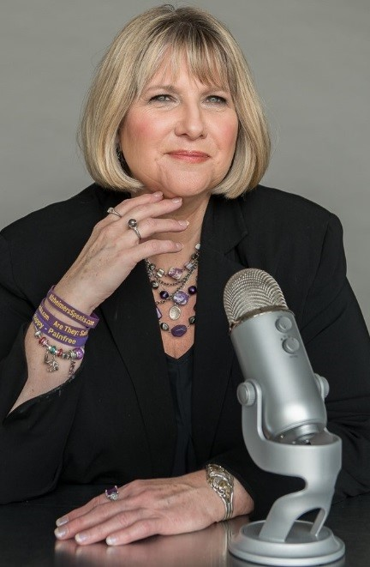 | Hailed as:  #1 Influencer Online for Alzheimer’s  - Dr. Oz and Sharecare  Health Hero - Oprah Winfrey  Architect of Change - Maria Shriver  Lori La Bey is a passionate advocate who searches for ways to shift our dementia care culture from crisis to comfort. She hosts Alzheimer’s Speaks Radio and the webinar series Dementia Chats. La Bey sparked the first Dementia Friendly Community in the United States, in Watertown, Wisconsin in 2013.  La Bey is hosting a day-long intensive session at the conference on Monday, March 26, titled Dementia Care is Changing, Are You?*  She will also be deliver a powerful plenary talk on Wednesday, March 28, entitled: Why Become Dementia Friendly – Impact, Rewards and Resources.
Deadline to reserve a guest room at conference venue, the Davenport Grand Hotel, is February 27. Room rates will increase and availability will be limited after that date.  Click here to book your hotel room at the Davenport Grand.  Northwest Rural Health Conference website | Early Bird registration price for the Northwest Rural Health Conference ends on March 4, 2018. Register now!  *Single day registrations are available for those who wish to attend Lori La Bey’s workshop only.  The NWRHC 2018 scholarship application deadline is February 28.Please find details about how to apply, here.

